# **Name: Abdurrahman Qureshi**

# **Roll No: 210451**

Practical No: 29

**1) Develop a program to draw a polygon**

**CODE:**

import java.awt.*;  
import java.applet.*;  
public class Main extends Applet {  
 public void paint(Graphics g) {  
 int[] xPoints = {100, 150, 200, 150};  
 int[] yPoints = {100, 150, 100, 50};  
 Polygon polygon = new Polygon(xPoints, yPoints, 4);  
 g.setColor(Color.red);  
 g.fillPolygon(polygon);  
 }}

**OUTPUT:**

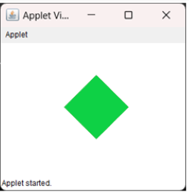

**2) Develop an applet for drawing a human face**

**CODE:**

import java.awt.*;  
import java.applet.*;  
public class Main extends Applet {  
 public void paint(Graphics g) {  
 g.setColor(new Color(50, 20, 20));  
 g.fillOval(80, 100, 250, 250);  
 g.setColor(Color.black);  
 g.fillOval(150, 175, 25, 25);  
 g.fillOval(225, 175, 25, 25);  
 g.setColor(Color.red);  
 g.drawArc(150, 225, 100, 50, 180, 180); }}

**OUTPUT:**

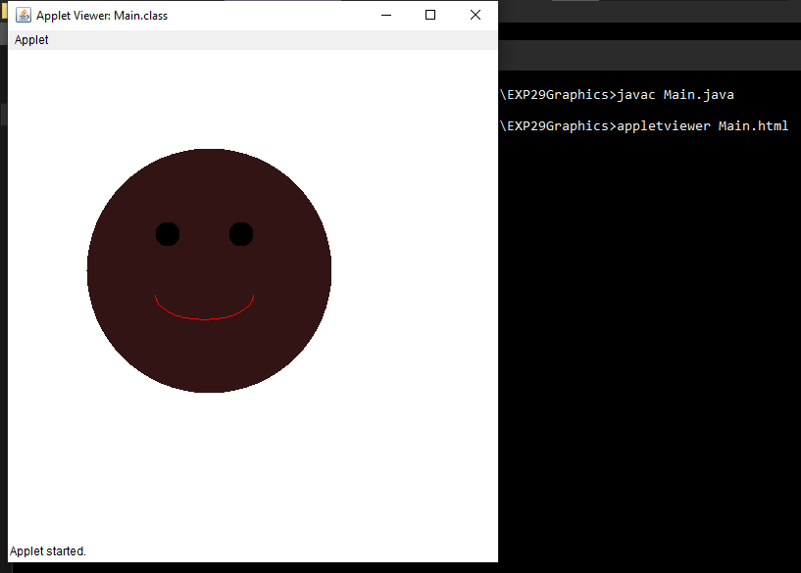

**3) Drawing circles with different colors**

**CODE:**

import java.awt.*;  
import java.applet.*;  
public class Main extends Applet {  
 public void paint(Graphics g) {  
 g.setColor(Color.CYAN);  
 g.fillOval(75, 50, 50, 50);  
 g.setColor(Color.BLACK);  
 g.fillOval(150, 50, 50, 50);  
 g.setColor(Color.RED);  
 g.fillOval(225, 50, 50, 50);  
 }  
}

**OUTPUT:**

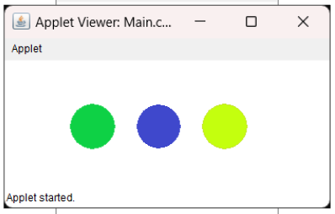

**4) WAP to create an applet for displaying circle, rectangle, triangle, round rectangle and fill them with different colors.**

**CODE:**

import java.awt.*;  
import java.applet.*;  
public class Main extends Applet {  
 public void paint(Graphics g) {  
 g.setColor(Color.CYAN);  
 g.fillOval(75, 50, 50, 50);  
 g.setColor(Color.BLACK);  
 g.fillOval(150, 50, 50, 50);  
 g.setColor(Color.RED);  
 g.fillOval(225, 50, 50, 50);  
 }  
}

**OUTPUT:**

